A Data Analysis Report On

**“SHOPNEST STORES SALES”**

*As a fulfilment of*

CAPSTONE PROJECT

(POWER BI)

Submitted By:

Animesh Nandy

**Submitted to:**

**SKILLOVILLA**

Shop-Nest Store Analysis report

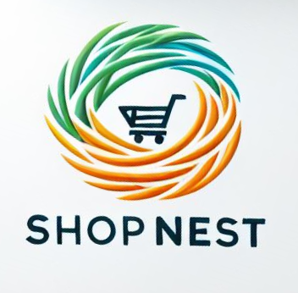

Shop-Nest, a leading department store in Portugal's e-commerce marketplace, plays a pivotal role in connecting small businesses from various regions across the country to a broader market. By serving as a seamless link, Shop-Nest enables merchants to showcase and sell their products efficiently through its platform, with the added convenience of direct shipment facilitated by Shop-Nest’s logistics partners.

This capstone project involves designing a comprehensive Power BI dashboard to analyse key business metrics and uncover insights from Shop-Nest’s anonymized commercial data. The project encompasses several analytical tasks, aimed at enhancing our understanding of sales performance, customer behaviour, and operational efficiency.

The provided datasets cover various aspects of Shop-Nest’s operations, including customer information, geolocation data, order items, payments, reviews, product details, sellers, and product categories. By integrating and analysing these datasets, the Power BI dashboard addresses the following critical business questions:

1. **Question Statement:** Identify the rating distribution in the Shop_Nest dataset, showcasing ratings categorized as Excellent, Very Good, Good, Bad, and Very Bad, along with corresponding orders.

**Visualization:**

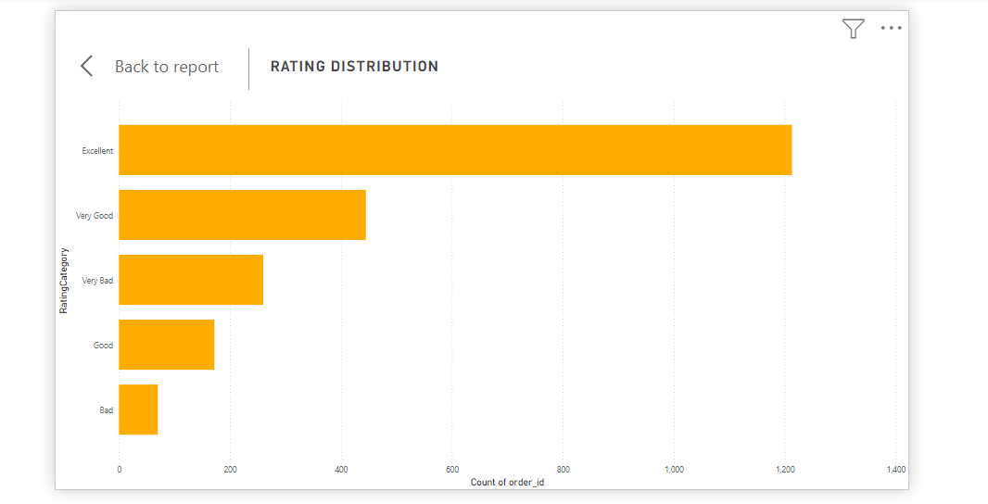

**Explanation:** above 50k orders are delivered with the rating of “Excellent”

very few orders are delivered with the rating “Bad”.

1. **Question Statement:** What are the top 10 and bottom 18 most popular product categories in the Shop_Nest dataset? Please list them based on the number of orders.

**Visualization:**

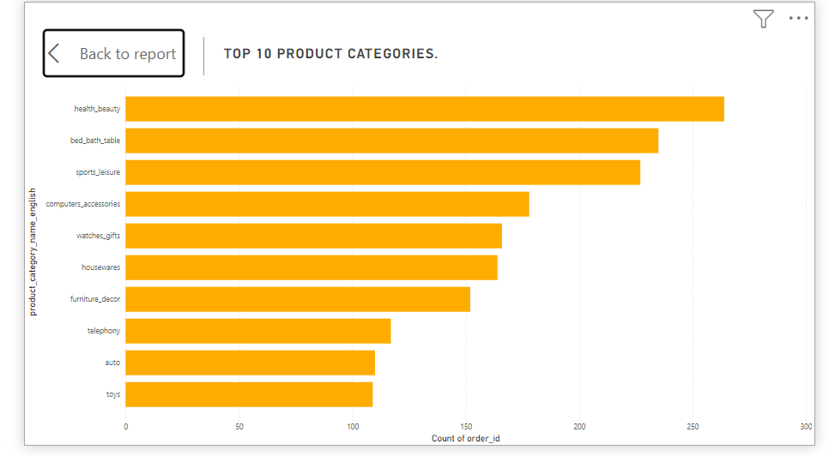

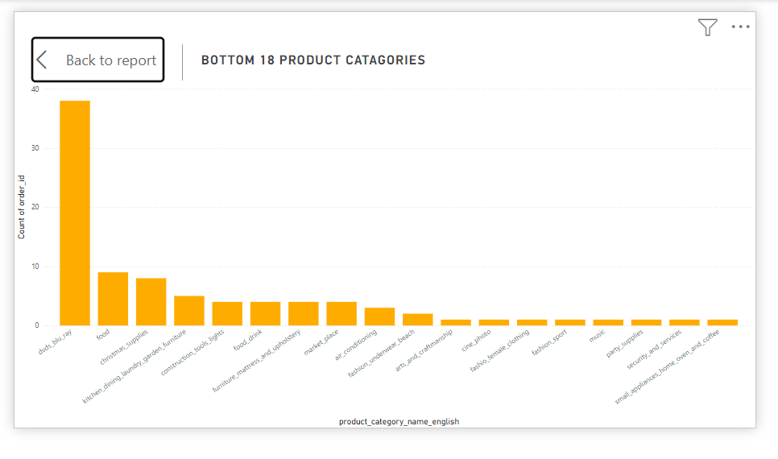

**Explanation:** here are the top 10 and bottom 18 product categories, here we can see that bed bath table is the top most category and Argo industry is most bottom product.

1. **Question Statement:** List the total number of active sellers by yearly and monthly

**Visualization:**

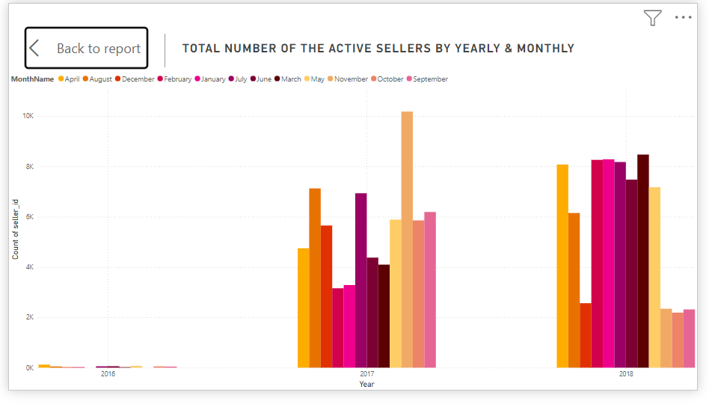

**Explanation:** there are more active sellers in 2018 , April and January.

There are less active users in 2016.

**4)Question Statement:** Which payment methods are most commonly used by Shop_Nest customers.

**Visualization:**

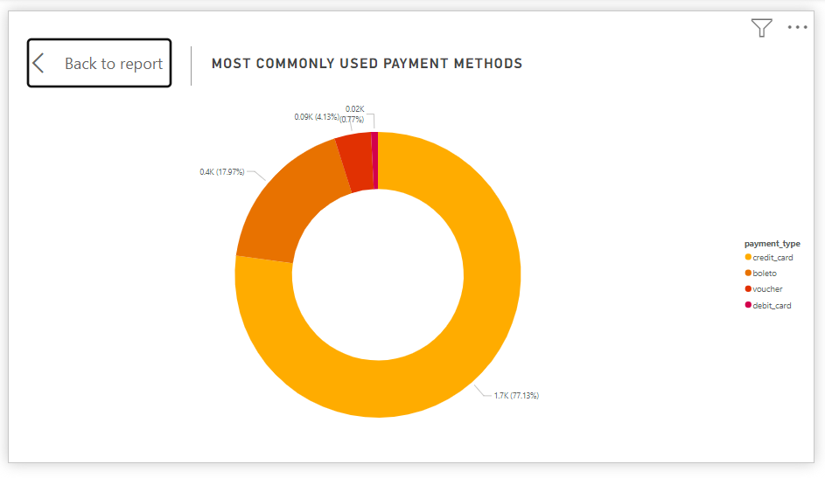

**Explanation:** 75% customers are using credit cards as the payment methods.

Very less customers are using debit card as the payment methods.

The analysis of payment methods is represented through a pie chart, providing a clear visual breakdown of the most frequently used payment methods by customers.

Key-Insights

• **Most Used Payment Method** – The pie chart helps identify that ‘Credit Card’ payment method are most popular among customers. This can indicate customer preferences and potentially inform strategic decisions around payment options. The payment method that is used most frequently, which might indicate customer trust and satisfaction with that method.

• **Least Used Payment Method** – Debit cards are identified as the least frequently used payment method. This insight can prompt an investigation into why this method is not as popular among customers.

• **Improving Less Used Methods** – Investigate why debit cards are less popular. Potential actions could include improving the user experience, offering incentives, or ensuring better security measures.

**6)Question Statement:** Determine the monthly payments made by customers using credit cards.

**Visualization:**

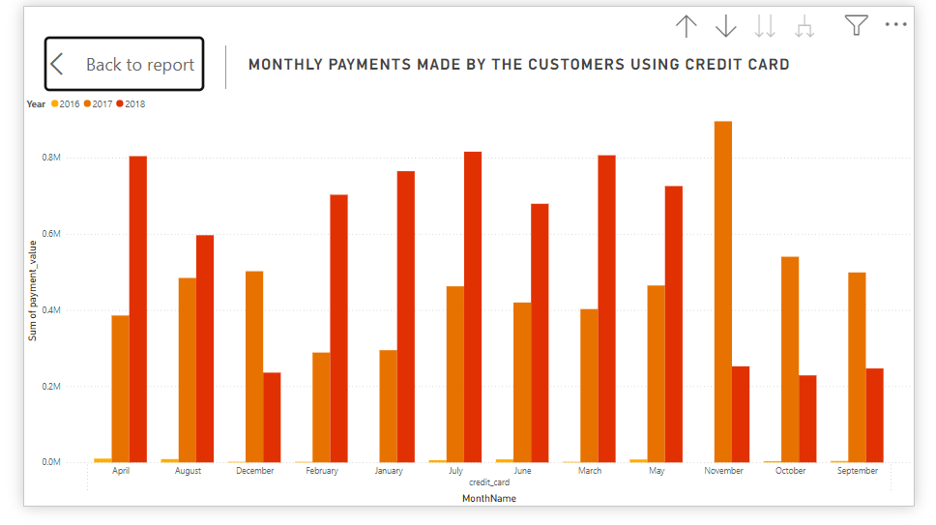

**Explanation:** In September 2016 payments by credit cards are the lowest.

In April, march, May 2018 payments by credit cards are the highest.

In November 2017 payments made by credit card are also the highest.

**7) Question Statement:** Identify sellers categorized by city, excluding cities starting with the letters S and B.

**Visualization:**

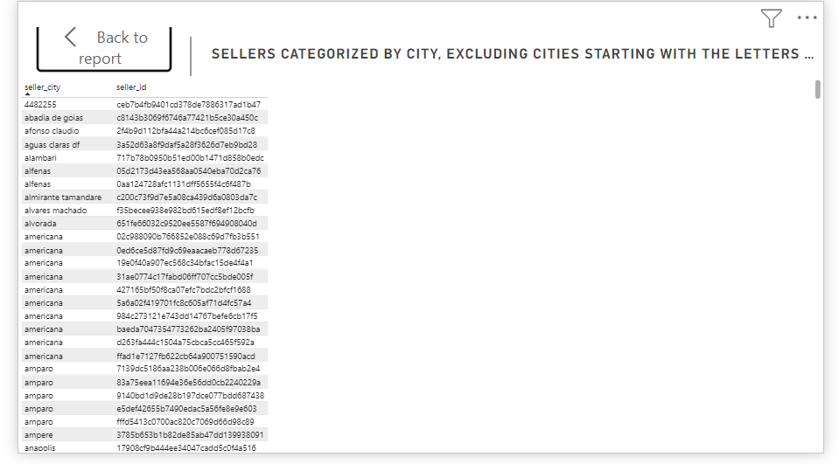

**Explanation:** here is the list of all the seller_ids which belongs to seller_city excluding city starts with b and s

**8) Question Statement:** Create a dynamic visual that compares the number of delayed orders to the number of orders received earlier for each month. Utilize the drill through the cross-report feature to provide a detailed analysis of late and on-time deliveries.

**Visualization:**

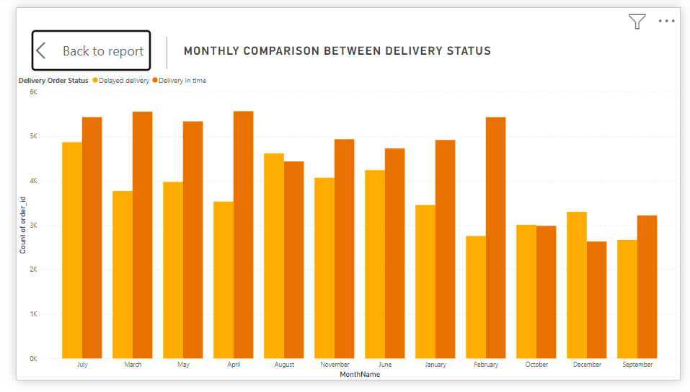

**Explanation:** on-time orders - high in august, low in September.

Delayed orders – high in March, low in September.

**CONCLUSION**

**Fulfilment Efficiency:**

Examining delayed orders provides valuable insights into fulfillment efficiency, uncovering potential obstacles in logistics and supply chain management. By tackling systemic issues and optimizing processes, businesses can improve order fulfillment and boost customer satisfaction.

**Payment Method Preferences:**

Credit cards have become the preferred payment method, reflecting customers’ desire for convenience and flexibility. By providing a variety of payment options, businesses can better meet diverse customer preferences and improve transaction efficiency.

**Product Satisfaction:**

Evaluating product ratings highlights the crucial role of product quality and customer experience in fostering satisfaction and loyalty. By utilizing insights from top-rated products, businesses can enhance their offerings and strategically invest to boost customer satisfaction.

**Strategic Implications:**

The insights derived from these analyses offer crucial guidance for strategic decision-making, resource allocation, and operational improvements. By harnessing actionable intelligence, organizations can streamline processes, enhance sales strategies, and achieve sustained growth and profitability in the competitive e-commerce market.

To sum up, having a deep insight into sales performance, fulfillment efficiency, customer preferences, and revenue trends enables businesses to make well-informed decisions and craft targeted strategies. This approach ensures sustained success and a competitive edge in the ever-evolving e-commerce landscape.

DASHBOARD

